1.

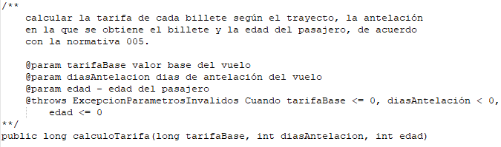

2.

|  |  |  |
| --- | --- | --- |
| Número | Clase de equivalencia | Resultado correcto / incorrecto |
| 1 | tarifaBase menor o igual a cero |  |
| 2 | tarifaBase mayor a cero |  |
| 3 | diasAntelacion menor a cero |  |
| 4 | diasAntelación mayor o igual a cero y menor o igual a 20 |  |
| 5 | diasAntelacion mayor a 20 |  |
| 6 | Edad menor o igual a cero |  |
| 7 | Edad mayor a cero y menor a 18 |  |
| 8 | Edad mayor o igual a 18 y menor o igual a 65 |  |
| 9 | Edad mayor a 65 |  |

3.

|  |  |  |  |  |
| --- | --- | --- | --- | --- |
| Caso | tarifaBase | diasAntelacion | edad | Resultado esperado |
| 1 | -100 | 10 | 20 | Error |
| 2 | 100 | 10 | 20 | 100 |
| 3 | 1000 | -10 | 20 | Error |
| 4 | 1000 | 10 | 20 | 1000 |
| 5 | 1000 | 100 | 20 | 850 |
| 6 | 1000 | 10 | -100 | Error |
| 7 | 1000 | 10 | 10 | 950 |
| 8 | 1000 | 10 | 50 | 1000 |
| 9 | 1000 | 10 | 80 | 920 |

4.

|  |  |  |
| --- | --- | --- |
| Número | Condición límite 1 | Condición límite 2 |
| 1 | TarifaBase igual a cero | tarifaBase igual a 1 |
| 2 | diasAntelación igual a -1 | diasAntelación igual a 0 |
| 3 | diasAntelación igual a 20 | diasAntelación igual a 21 |
| 4 | Edad igual a 0 | Edad igual a 1 |
| 5 | Edad igual a 17 | Edad igual a 18 |
| 6 | Edad igual a 65 | Edad igual a 66 |

5.

|  |  |  |  |  |
| --- | --- | --- | --- | --- |
| Caso | tarifaBase | diasAntelacion | edad | Resultado esperado |
| 1 | 0 | 10 | 20 | Error |
| 2 | 1 | 10 | 20 | 1 |
| 3 | 1000 | -1 | 20 | Error |
| 4 | 1000 | 0 | 20 | 1000 |
| 5 | 1000 | 20 | 20 | 1000 |
| 6 | 1000 | 21 | 20 | 850 |
| 7 | 1000 | 10 | 0 | Error |
| 8 | 1000 | 10 | 1 | 950 |
| 9 | 1000 | 10 | 17 | 950 |
| 10 | 1000 | 10 | 18 | 1000 |
| 11 | 1000 | 10 | 65 | 1000 |
| 12 | 1000 | 10 | 66 | 920 |